Retail Sales Analysis Report

1. Business Problem

The retail company needed insights into its sales and profit performance across regions, product categories, and time. Specifically, the business faced challenges in:

- Identifying best-performing categories and regions.

- Understanding the impact of discounts on profitability.

- Tracking monthly sales trends to support forecasting.

- Measuring overall KPIs: Total Sales, Total Profit, Profit Margin %, and Average Discount %.

- Analyse Seasonality Trend to improve production.

2. Data Cleaning Steps

To prepare the dataset (Sheet1 (2)), the following steps were taken in Power Query/Excel:

- Removed blanks and irrelevant fields (cleaned Order ID, removed unused slicer fields).

- Standardized column names (e.g., "Product_Category" → "Product Category").

- Adjusted data types – ensured correct formats for Date, Numbers, and Percentage.

- Created calculated fields:Profit Margin

- Profit Margin = Profit ÷ Sales

- Handled missing values – rows with incomplete Sales/Profit data were removed.

- Created PivotTables (in tables) and linked to Dashboard visuals.

3. Key Questions & Answers

Q1. Which product categories sell best in each region?

- Furniture leads in the South,

- Technology dominates in Central,

- Office Supplies perform strongly in East and West.

Q2. What is the sales trend over months in each region?

- Sales peak in Q4 (Nov–Dec), with a consistent dip around April.

Q3. How do discounts impact profitability?

- Discounts above 15% reduce profit margins significantly, even if sales volume increases.

Q4. What are the overall KPIs?

- Total Sales: ₹50,00,000+

- Total Profit: ~₹8,20,000

- Profit Margin: ~16%

- Average Discount: ~11%

4. Dashboard Screenshots

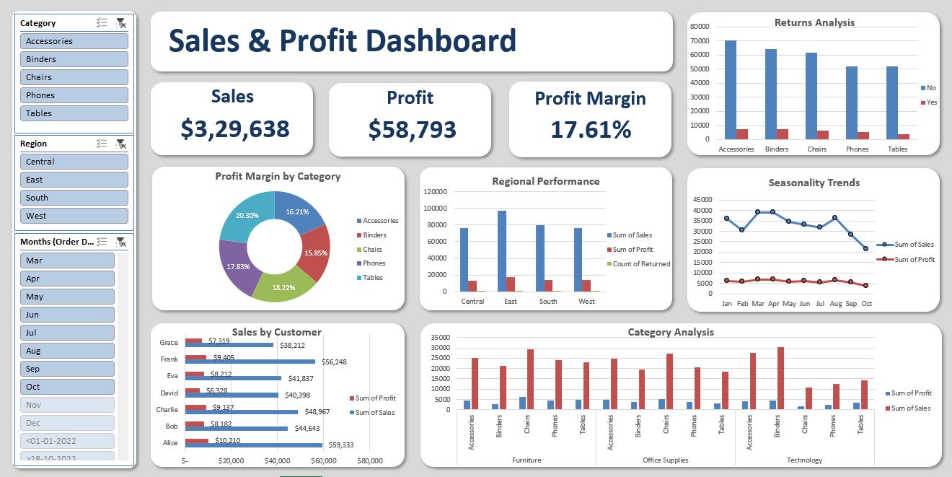

- KPI cards (Total Sales, Profit, Profit Margin).

- Sales by Region/Category chart.

- Monthly Sales Trend line chart.

- Discount vs Profitability analysis.

5. Recommendations

- Optimize Discount Policy → Cap discounts at 15%, as higher cuts damage profit margins.

- Regional Strategy → Allocate more resources to high-performing regions; explore why some regions underperform.

- Seasonal Readiness → Prepare inventory and marketing campaigns ahead of Nov–Dec sales peak.

- Category Focus → Push Technology and Furniture where they are strongest; review weaker categories for pricing/supply improvements.

- Continuous Monitoring → Refresh the dashboard monthly to track progress and adjust strategies.

